Timber Component Installation Interactive Learning Tools (BWF 18-01)
Launch/Final Project Report (Period Reference P5.1 & 6.1)

Background to the Project
Despite major advancement in the design, testing and production of pre-manufactured components, on-site inefficiencies remain common for the installation of specific timber products such as timber fire door assemblies, timber stairs and timber windows.
The apparent lack of skills and knowledge associated with product installation normally results in poor quality workmanship and ultimately a poor-quality installation of the product, causing defects and client complaints (e.g. squeaky stairs, leaking or early failure of windows or well-reported issues with timber fire door installations). These can lead to breakages, complete product failure and, in worst-case scenarios, accidents or fatalities. The reporting of product installation issues often necessitates the need for frequent site visits by the manufacturer to survey and problem troubleshoot, creating delays in the project delivery, increasing costs, therefore reducing viability and productivity of the installation and wider construction process.
Specialist installation training provision (beyond entry level through appropriate NVQs and apprenticeships) is virtually non-existent and, where training has taken place, it is often aimed at general site product installation and not specific to the installation of modern pre-manufactured timber components. Whilst installation guides have been developed and are freely available throughout the site installer network, these often make for heavy reading and usage, prior to and at the point of installation is hence limited.

Introduction to the Project
Discussion with clients, contractors and installers confirmed that there are gaps in skills and knowledge required for the installation of timber components and products, further supported by findings that call-back to site to investigate defects and failures are predominantly due to poor quality installation rather product faults. Common areas of reported poor quality installation include unsecured staircases, stairs out of level, fire door gaps incorrect, poorly installed ironmongery, windows incorrectly installed or not sealed, and door frames fitted out of square. Such situations can be reduced and largely eradicated through the introduction of appropriate blended learning solutions, ensuring that suitable measures are available to the existing and future installer network.

To address this need, the British Woodworking Federation (BWF) and key sector representatives, have produced three interactive learning tools, derived from content set down in the relevant installation guides for timber fire door assemblies, timber stairs and timber windows.

The interactive learning tools will help to confirm the standard for the installation of straight flight timber stairs, timber windows and timber fire doors, closing the knowledge and skills gap for existing workers as well as supporting learning for future workers. This will be achieved by making the Interactive learning tools available to the sector to enable the delivery of up-to-date, quality training solutions. The interactive learning tools will use a combination of animation and interactive assessment to attract and engage the user, encourage upskilling and refresher training and support existing delivery methodologies.

The Aim of the Project
The aim of this project was to extend and enhance provision for the development and delivery of fit for purpose interactive learning tools based on common, industry recognised standards for the installation of:
- timber fire door assemblies
- timber stairs (straight flight)
- timber windows

The Objectives of the Project
To achieve the established aim, the project has met the following objectives:
- Utilised recently reviewed and updated BWF installation guides for timber fire door assemblies, timber stairs and timber windows to produce three new interactive learning tools.
- Engaged with key industry stakeholders to investigate best practise and support the development of and delivery of three high-quality training solutions.
- Engaged with a selected cohort of sector specific stakeholders to test and trial the three developed interactive learning tools.
- Marketed, promoted and launched the interactive learning tools to BWF members in a manner that maximises their potential use to support reduction in the knowledge and skills gap of existing installers.
- Implemented detailed planning on methodologies to launch the interactive learning tools to the wider construction sector.
- Implemented detailed planning to review and evaluate the interactive learning tools and their use, to ensure that the project has and continues to reach its full potential and maximum value to the woodworking sector and wider construction industry.

The Outcome of the Project
This project has produced and provided the woodworking and joinery manufacturing sector, and wider construction industry with a valuable set of fit for purpose interactive learning and assessment tools, designed to assist in bridging the perceived gap in the installation of specified timber components, increasing awareness and the wider considerations when installing timber fire door assemblies, straight flight timber stairs and timber windows. The project has also looked to pinpoint existing and new training delivery methodologies, to ensure that the interactive learning tools are utilised effectively and can add value and maximum benefit to the end-user and wider construction sector.

Project Challenges
The project experienced several key challenges over the duration of the development and launch stages.
- COVID 19 Outbreak - At the request of CITB, the project was delayed by two full quarters from a delivery perspective. This had a knock-on effect to the project development process, caused in the main by delays to the development of the final voiceover/recording studio work. The development process was further delayed by the two lockdown periods inflicted during the COVID pandemic.

- Extended Product Testing - On development of the three Interactive Learning Tools (ILT’s), issues were identified with the quality and smooth operation, dependent on the capabilities of the IT equipment being used to operate them by the end user. Extensive testing and constant improvements were made to the ILT’s, to help ensure that the tools could be optimised by learners using with low specification IT equipment.

- Accessing the ILT’s - The decision was taken to make further investment and allow further development time for the development and implementation of a voucher/token system to help to manage and streamline access for users completing the ILT’s on either a free of charge or paid basis.

- ILT Security Development - Further investment and development time was agreed to develop and integrate a bespoke security system, designed to protect multiple use of the ILT’s from a user perspective and to ensure that all content was protected from collection and use in subject related training solutions, developed by other providers.

- Platform Issues - On completion of the ILT’s, difficulties were encountered when attempting to get the EPIC and BWF platforms to communicate and interact with each other. This resulted in an additional phase of ILT reprogramming to overcome this issue.

- BWF Members area – The intention was always to confine the ILT’s within an area accessible to members only during the initial launch of the tools. Extensive delays were experienced during the development of the new BWF members area, which resulted in further delay to the scheduled soft project launch.

Outcomes of the Development Process
The following links and supporting information have been provided for the purposes of this report only. Please do not share or use these links and access codes for any use other than viewing the final products as part of this reporting process. Please delete when their use is no longer required.
Links to the final ILT’s can be found here. https://bwf.learning-hub.co.uk/
Codes to access the ILT’s are here:
- JMP2021bwfdIWStbVJmQZqYN6gUS282OF8n7A3hs
- JMP2021bwffYDfoGvuo99QPVe4ltWAiPBC4jLZ4N
- JMP2021bwfl4cHd90zvZ0sdUhVxg13Ayye8zt3Xw

Pre-launch Requirements for the Timber Component Interactive Learning Tools
In preparation for launching the ILT to BWF Members, a significant amount of development work was undertaken to the members’ only area of the website to ensure the functionality of the software would perform as intended.
This piece of work was used to drive the development and implementation of a vastly improved members’ only area that allowed Members to easily access resources specific to their membership such as the ILT’s.

Accessing the Timber Component Interactive Learning Tools
The decision had been made to launch the ILT to BWF Members only in the first instance which meant a system needed to be developed to ensure we could monitor access.
A process that involved creating and disseminating unique token codes was created meaning that a learner would require a token to access each of the modules and that token could only be used once.

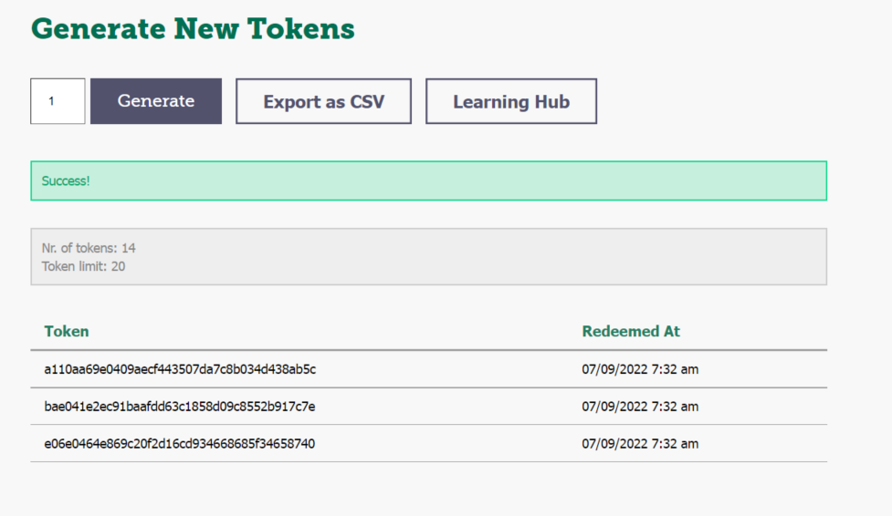

From the Members’ area of the website, Members can generate the number of tokens they need for themselves, or for their team, to take one or all three of the ILT modules. The tokens are then used to activate their registration on the ILT platform so that the learner can start their learning.

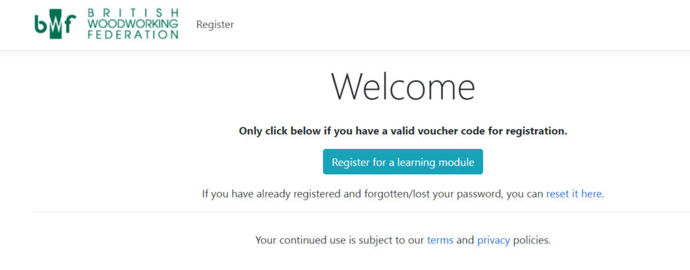

Launching the Timber Component Interactive Learning Tools (Soft Launch to Members)
The decision was made to initiate and action a soft launch to BWF Members to create a controlled user environment, to ensure the software and system functionality performed correctly when being accessed by multiple users. This would allow any issues to be identified and resolved, prior to launch to the wider construction industry.
The launch process began at the BWF Members’ Day, which took place on the 21st June 2022. A BWF Interactive Learning stand was set up for members to visit throughout the day, which was attended by over 120 delegates. The Interactive Learning Tool for timber stairs was available for demonstration purposes and for members to access and try out the learning experience. The Interactive Learning Tool development agency, Jump (GB) Ltd, were also in attendance, on hand to provide further information on the development process, member usability, and rationale for functionality.

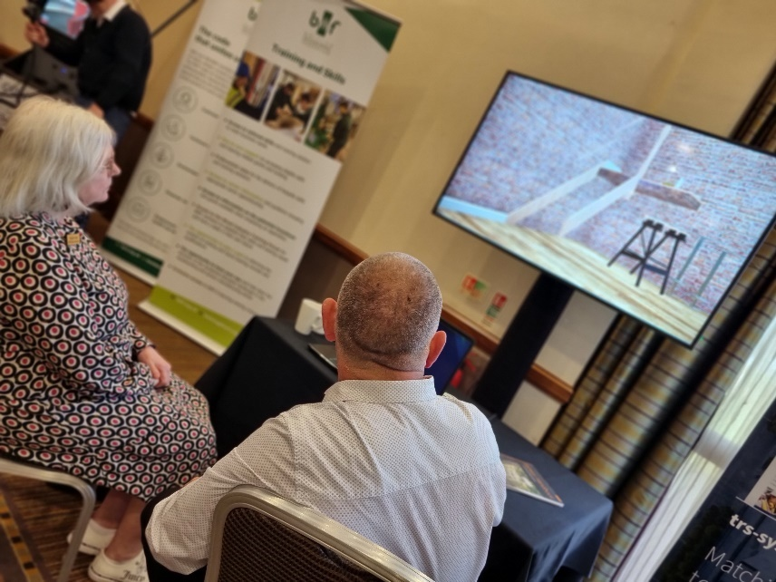
There was lots of interest in the ILT’s throughout Members Day and the feedback given by members experiencing this form of learning for the first time was extremely positive.
Example of feedback quotes Recorded at Member’s Day:
It’s great to have access to useful training in a way that’s truly useful and flexible for my staff.

This will help my joiners to understand what really goes on during stair installation on site

I think these tools will help to cut down on poor quality installation of my products.

On the back of the BWF Members Day, further communication was sent out to all BWF members via the Skills and Training update in early August 2022, introducing the new ILT’s and providing clear instructions on how to access and use the learning platform.
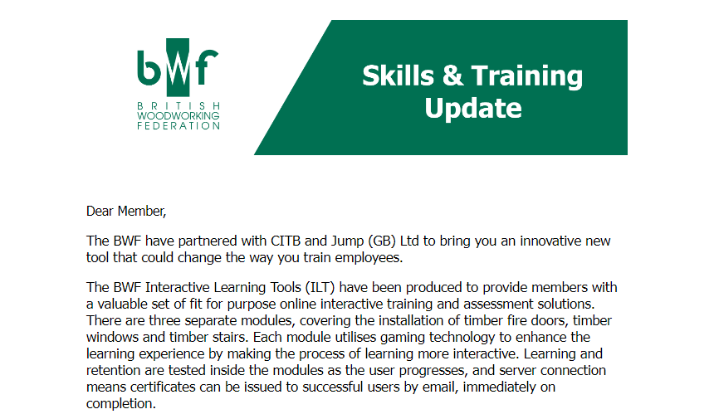

The BWF have also continued to communicate with all BWF members via regular member focussed newsletters and other updates to showcase the new interactive learning tools and assist them with accessing it when necessary. This communication process will continue at regular intervals throughout the remainder of 2022.

Planning to Launch to the Wider Construction Sector
In order to launch the Interactive Learning Tools to non-members, a new landing page will be added to the BWF website to showcase each learning tool. This page will be located and available to view within the existing and established A-Z course finder within the BWF Education section.

Non-members will be able to purchase tokens from the BWF online shop. These tokens will allow an employer and/or individual learner to access the interactive learning tools and commence with the training.
How will the BWF Launch to the Wider Construction Sector
The ILT will be launched to non-members using a variety of digital platforms and communication channels.
Press Release – BWF’s PR agency, Speed Communications, will draft a press release that will go out to a range of trade and industry journals detailing the new learning opportunity available via the BWF. This press release will discuss the importance of skills and training, and how important it is to adapt methods of learning that will attract the future generations in the woodworking and joinery manufacturing sector and wider construction industry. The release will detail how the gaming technology used within the Interactive Learning Tools provides an innovative way of attracting existing and particularly new learners by delivering a user format familiar with the same controls used for other IT based leisure activities.
Social Media – The BWF will use each of our social platforms (predominantly Linkedin, Twitter and Facebook) to promote the Interactive Learning Tools to the widest possible audience, mirroring the narrative of the press release.
Email Comms – The BWF will include links to the Interactive Learning Tools in our acquisition comms that are used to target new Members to the BWF. We will use the tools to demonstrate our commitment to training and how we adapt to the needs of the next generation when it comes to training delivery and teaching methods.

Maintaining and Sustaining the Timber Component Interactive Learning Tools
The BWF will undertake scheduled review of all interactive learning tools to ensure that they remain fit for purpose and up to date. Whilst every effort has been taken to utilise generic terminology where possible, changes to existing working practices, regulations, and official guidance in the future, will have the potential to impact on existing learning tool content.
This will be closely monitored, along with structured feedback received form employers and learners using the Interactive Learning Tools, and relevant updates will be undertaken accordingly.

Evaluating the Timber Component Interactive Learning Tool Project
The final phase of the launch process will see the introduction of the interactive learning tools to the wider construction sector. At the point at which the BWF feel that the tools have been available and used in appropriate numbers, project evaluation will be undertaken with both members and non-members, using a blend of evaluation methodologies including:
- Online Survey
- Case Studies
- Telephone interviews (if and where appropriate)
The evaluation will look to collect data on change of knowledge, skills, and attitudes resulting from the use and completion of the Interactive Learning Tools. It will also look to identify employer data, including size, location, sector, and sub-sector, as well as complementing individual learner data where possible. On completion, the evaluation findings will be collated and sent to the funding commissioner at CITB.

How Could CITB Support the Launch Process
CITB could support the BWF launch to the wider construction industry launch by undertaking the following actions:
- Provide a quote about the project for use within the press release (BWF to share).
- Like and share social media posts (BWF to tag CITB).
- Populate the CITB Funded Projects Library web page with a brief commentary showcasing the Interactive Learning Tool project with a link to the ILT landing page.
- Utilise CITB media opportunities to discuss new ways of learning and sharing the ILT as an example.
End.

